**Supplementary Information**

Table 1:



Table 3:



Figure 1:

* 1st panel shows mean annual precipitation in mm, with average from 1983 – 2018 as a dashed line
* 2nd panel shows the value of the SPEI index over the course of our study, standardized relative to climate patterns from 1983 – 2018.
* 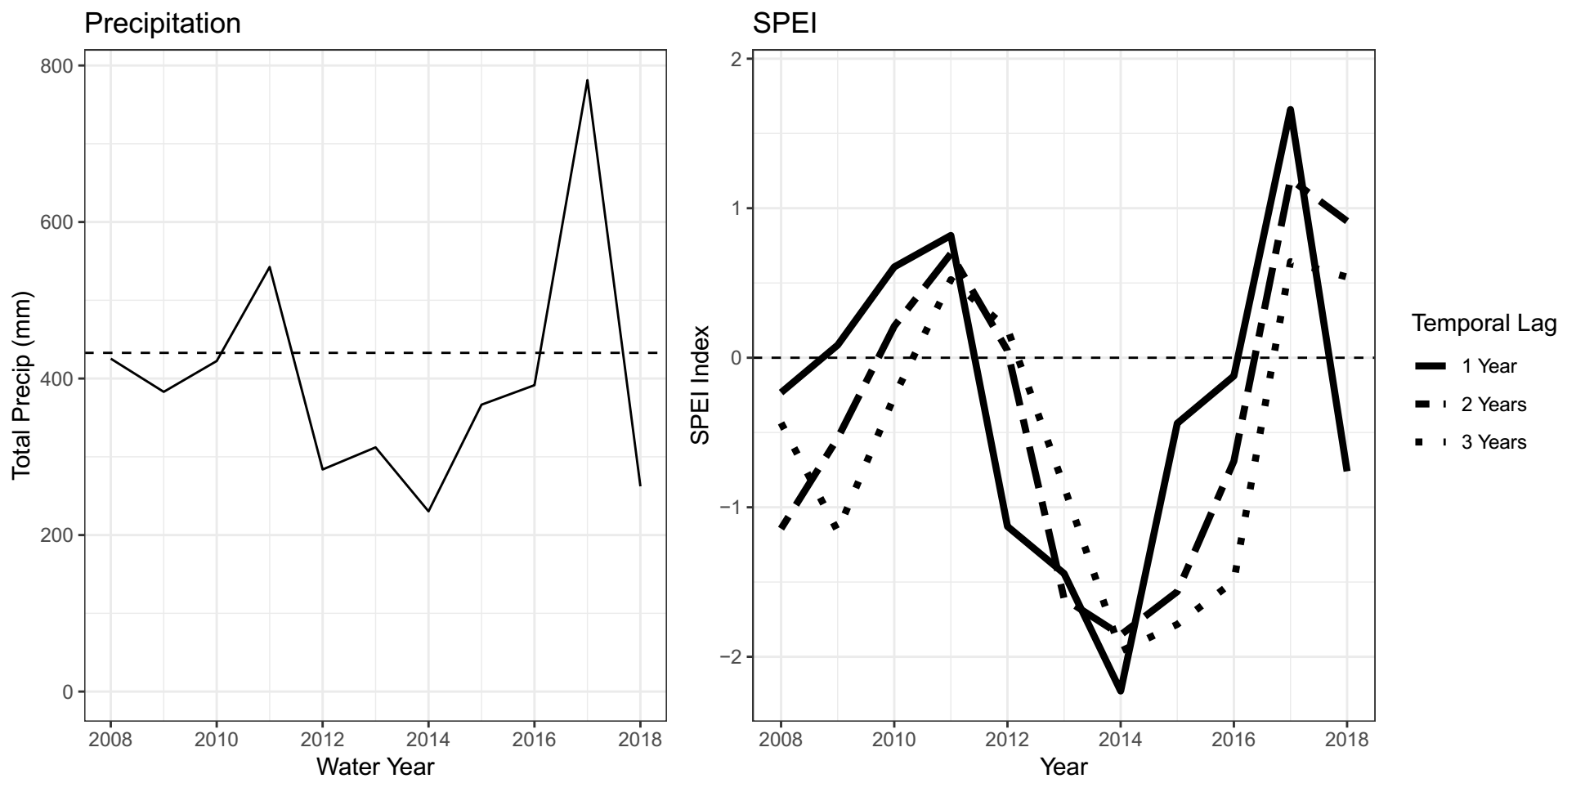
* Figure 5:
* 